**Assisted Practice: 2.2 Constructors**

This section will guide you to:

* Create a Java project in your IDE
* Write a program in Java to create constructors

This lab has three subsections, namely:

* + 1. Writing a program in Java to verify the implementations of constructor types
    2. Executing the program and verifying constructors
    3. Pushing the code to your GitHub repositories

**Step 2.2.1:** Write a program in Java to verify the implementations of constructor types

There are two ways you can perform this step; you can create a new Java project, or you can create a new Java class in the existing project. It is preferable to create a new Java class in the existing project but feel free to explore the first option. The steps mentioned below will work once you create a project in Java.

* Open Eclipse
* *[Right click]* on the **src** folder of the project
* Select *New* -> *Java Class* -> Enter the filename (follow camelCasing)
* Execute the code below resolving the warning and errors due compatibility-related issues

//default constructor

**package** Constructors;

**class** EmpInfo {

**int** id ;

String name;

EmpInfo(**int** i,String n){

id = i;

name = n;

}

//method to display the values

**void** display(){System.***out***.println(id+" "+name);}

**public** **static** **void** main(String[] args) {

EmpInfo std1 = **new** EmpInfo(2,"sunny");

EmpInfo std2 = **new** EmpInfo(10, "Annie");

std1.display();

std2.display();

}

}

**Step 2.2.2:** Executing the program and verifying the constructors

Before you execute the program, check for syntactical corrections. If no errors are found, follow the steps mentioned below:

* ***[Right click]*** in the program space
* Select *Run As Java Application*

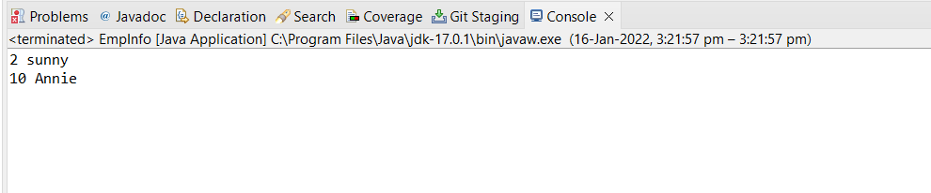

**Step 2.2.3:** Pushing the code to your GitHub repositories

* Open your command prompt and navigate to the folder where you have created your files.

**cd <folder path>**

* Initialize your repository using the following command:

**git init**

* Add all the files to your git repository using the following command:

**git add .**

* Commit the changes using the following command:

**git commit . -m “Changes have been committed.”**

* Push the files to the folder you initially created using the following command:

**git push -u origin master**